Exercise

1. Import the data set (’Exercise – Lab 05.txt’) into R and store it in a data frame called ”Delivery Times”.



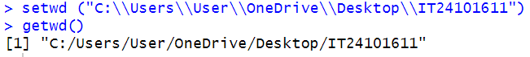

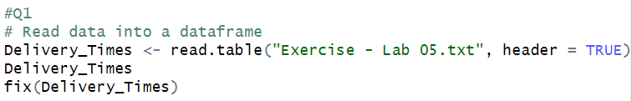

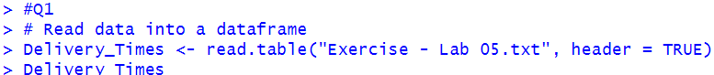

2. Draw a histogram for deliver times using nine class intervals where the lower limit is 20 and upper limit is 70. Use right open intervals.

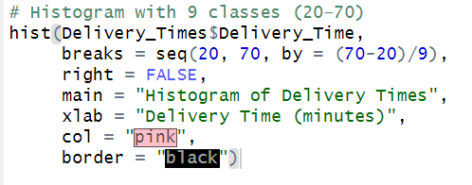

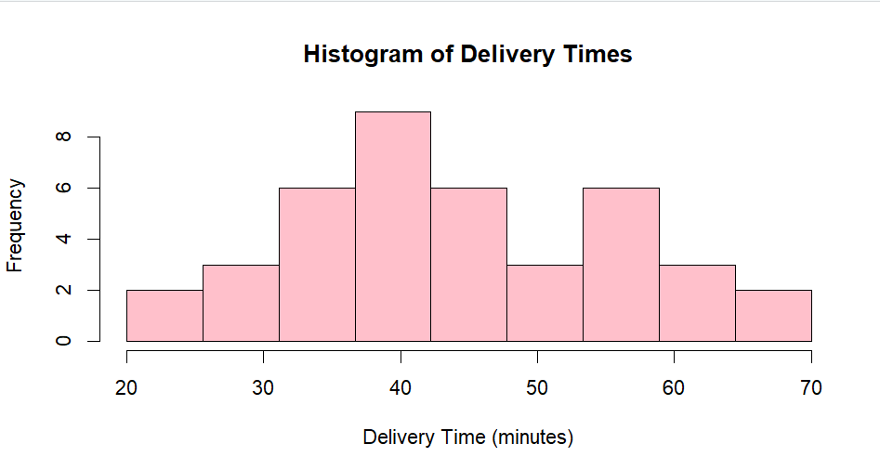

3. Comment on the shape of the distribution.

The histogram shows a right-skewed distribution, with most of the delivery times concentrated at the lower end, and a few higher values extending the tail to the right.

4. Draw a cumulative frequency polygon (ogive) for the data in a separate plot.

